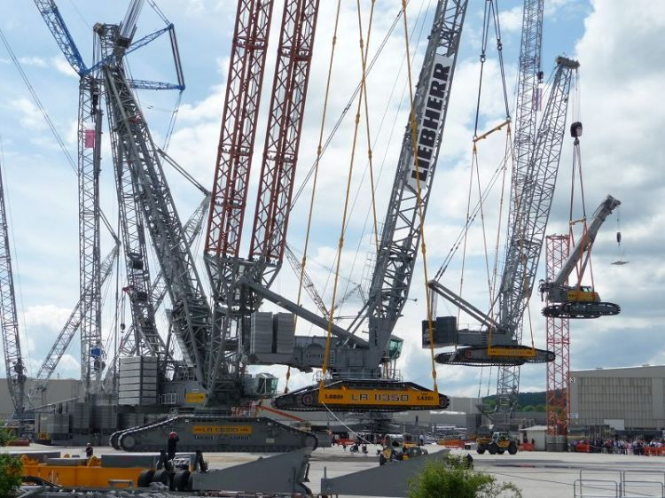

Construction systems (structural components)

By

Linchong Pan

100571672

Apply Structural Principles to Residential Low-rise Constructions

CPCCBC4010B

Submission date

Sunday, 7 October 2018

The date field is called a dater and is also active, just click and a date picker control box will appear

# Contents

Contents ii

Table of Figures ii

Introduction 3

Details 4

Conclusion 9

References 9

# Table of Figures

Figure 1 Evaluation of environmental impacts and health and safety risks (Gangolells, 2018) 8

# Introduction

Provide details on the construction systems adopted for a low-rise residential construction project and how the construction will be coordinated and managed within the project as a whole:

* claddings
* glazing & joinery
* stairs
* services
* health & amenity, fire, access, air handling
* Environmental impacts – e.g. energy efficiency, water recycling
* waterproofing – general & specific

# Details

Claddings

In order to bracing the structure and enforce the external wall, claddings are often used. The looks of claddings is also important consider that it’s the outside of the building after construction finished.

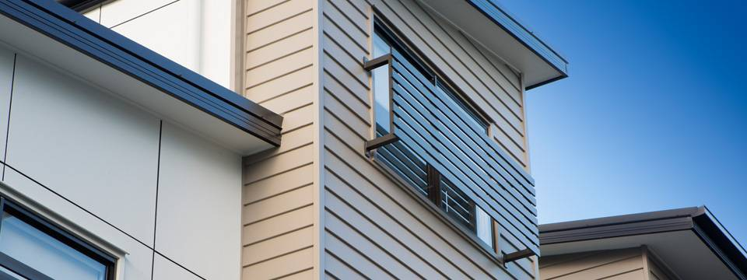

There are design standards for claddings, for example, wind forces in local environment (wind pressure on the building in different seasons). The following procedures are applied when prepare the requirements:

* Determine the wind classification by reference to AS 4055 Wind loads for housing and AS/NZ 1170.2 Structural design actions – wind actions.
* Determine the wind pressure by the wind classification and building width. See Tables 8.1 to 8.5 of AS 1684.2 Residential timber framed construction – non-cyclonic areas
* Determine the elevation by calculating the worst direction of wind on the structure and bracing can then be designed for the most adverse situation. See Table 8.3.6.6 in AS 1684.2 Residential timber framed construction – non-cyclonic areas.

Glazing & joinery

Glazing requirements should comply with AS 1288 Glass in Building. Typical products have different leaded materials and design consider the different required functions.

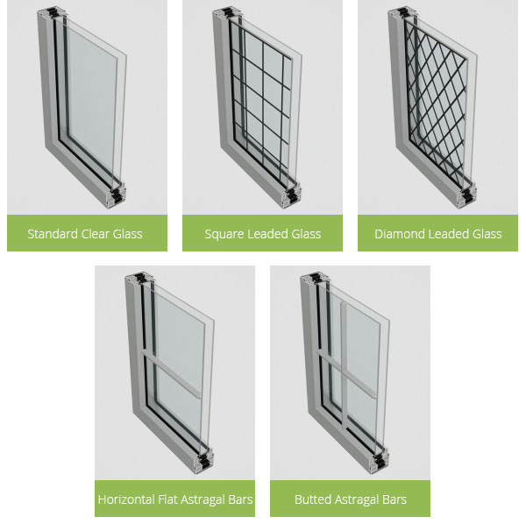

Glazing provides not only the heat isolation but also the looking of the overall design of the buildings.

Stairs

The starts contain floor landing as well as the mid-landing area.

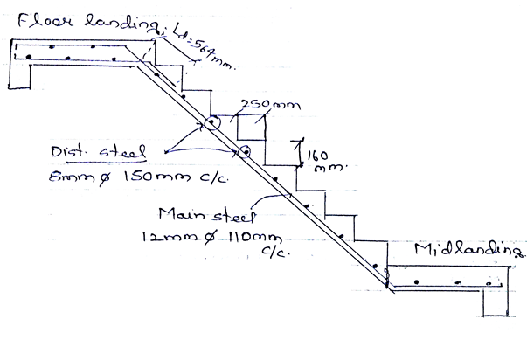

Services

In a project which requires plumbing and drainage work, especially when the contract need to deal with complex hot and cold water, gas. The services specification and manufactures’ instructions should fetch and detailed in the documents.

Health & amenity, fire, access, air handling

The demolition of an existing structure is subject to the Occupational Health and Safety Act 2004 (Vic) with amendment. With reference to Part F2.2.1 and the performance requirement in Part 2.2.1, note that the NCC describes dampness as being unhealthy, causing loss of amenity for building occupants and possible deterioration of building elements (Reference: NCC, Part 2.2.3). The safety standards of all building operations are likewise monitored and approved according to the Occupational Health and Safety Act 2004 (Victoria) and relevant amendments.

The overall process can be called as safe design, a typical model is shown below:

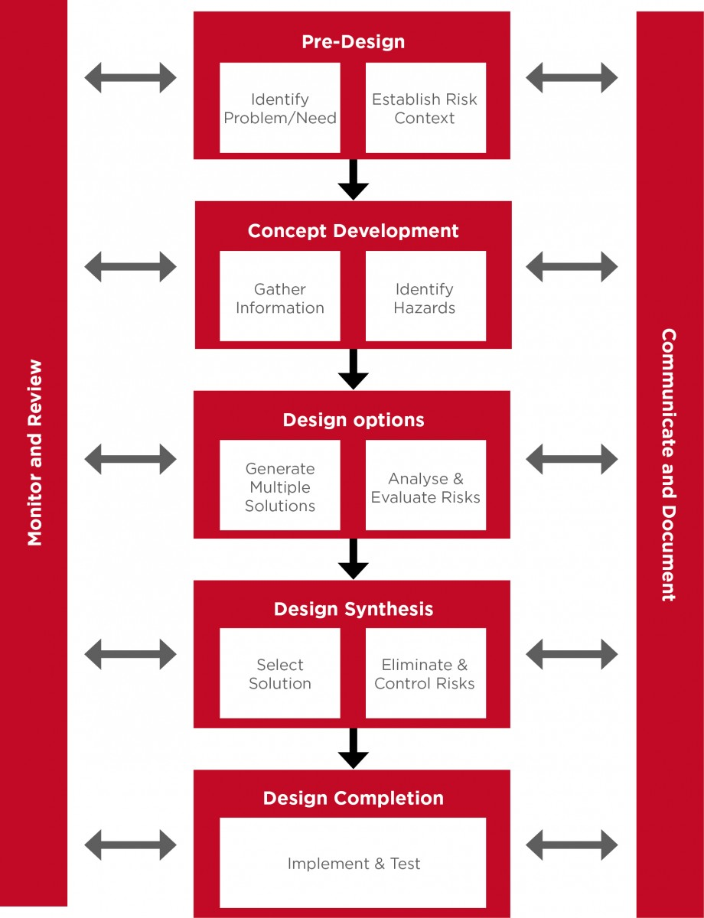

Environmental impacts – e.g. energy efficiency, water recycling

Before and during the building project, the environmental impacts of certain project should be evaluated and monitored. The table listed below indicates the risk level of water consumption during the construction process, large usage may result negative impact towards to surrounding area.

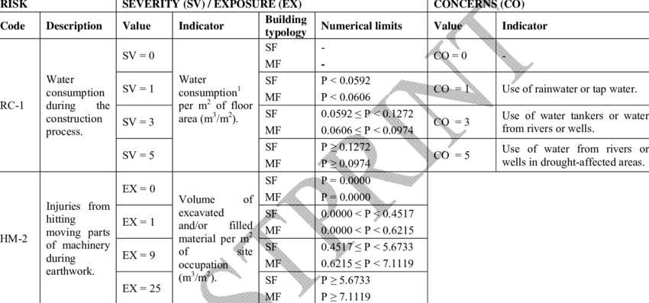

Figure Evaluation of environmental impacts and health and safety risks (Gangolells, 2018)

Waterproofing – general & specific

Waterproofing at this stage (claddings, glazing & joinery, stairs) has small difference then flooring,

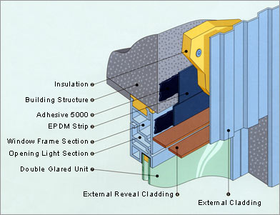

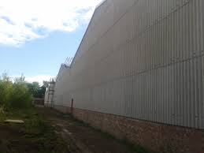

The above pictures shown the structure of waterproofing in low rise project.

# Conclusion

It is important to provide details claddings, glazing & joinery, stairs, waterproofing – general & specific during the product when preparing the Structural Principles

# References

Australia Standards, 1992. *AS2124 General Conditions of Contract,* Sydney: SAI global.

Australia Standards, 2002. *AS4915 Project Management,* Sydney: SAI global.

Australian Standards, 2002. *AS 1170 0.1 Structural Design Actions Part one: Permanent, Imposed and Other Actions,* Sydney: SAI global..

Gangolells, M., 2018. *Evaluation of environmental impacts and health and safety risks.* [Online]   
Available at: https://www.researchgate.net/figure/Evaluation-of-environmental-impacts-and-health-and-safety-risks-related-to-the_tbl1_260848394

SAI global, 2004. *HB 240-2004 Guidelines for managing risk in outsourcing,* Canberra: s.n.

SAI global, 2004. *HB 436: 2004 Risk management guidelines companion to AS 4360: 2004,* Canberra: s.n.